**CP Club 365Days Challenge**

**Date – 30/11/2022**

**Programming language – Any language**

**Problem Statement**

[https://practice.geeksforgeeks.org/problems/k-largest-elements4206/1?page=2&difficulty[]=1&category[]=Arrays&sortBy=submissions](https://practice.geeksforgeeks.org/problems/k-largest-elements4206/1?page=2&difficulty%5b%5d=1&category%5b%5d=Arrays&sortBy=submissions)

**Your Code**:

// 0x44Day of 0x365Days challenge

// VEDANT BHARAD

// 30-11-2022

//{ Driver Code Starts

#include <bits/stdc++.h>

using namespace std;

// } Driver Code Ends

//User function template for C++

class Solution{

public:

    vector<int> kLargest(int arr[], int n, int k)

    {

        vector<int> ans;

        // 1 fastest solution

        priority_queue<int,vector<int>,greater<int>>p;

        for(int i=0;i<n;i++){

            p.push(arr[i]);

            if(p.size()>k)

                p.pop();

        }

        while(p.size()>0){

            ans. push_back(p.top());

            p.pop();

        }

        reverse(ans.begin(),ans.end());

        //2

        // sort(arr, arr + n);

        // int con=1;

        // ans.insert(ans.end(),arr[n-1]);

        // n=n-1;

        // while (con<k)

        // {

        //     if(arr[n]!=arr[n-1])

        //     {

        //         ans.insert(ans.end(),arr[n-1]);

        //         con++;

        //     }

        //     n--;

        // }

        return ans;

    }

};

//{ Driver Code Starts.

int main() {

    int t;

    cin >> t;

    while (t--) {

        int n, k;

        cin >> n >> k;

        int arr[n];

        for (int i = 0; i < n; i++) {

            cin >> arr[i];

        }

        Solution ob;

        auto ans = ob.kLargest(arr, n, k);

        for (auto x : ans) {

            cout << x << " ";

        }

        cout << "\n";

    }

    return 0;

}

// } Driver Code Ends

**Output (Screen Shot)**:

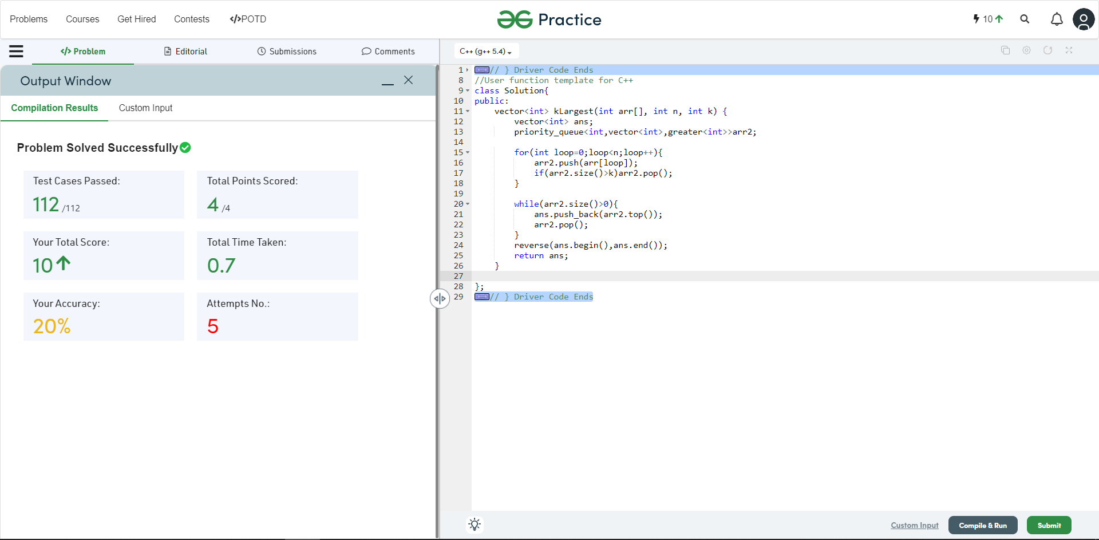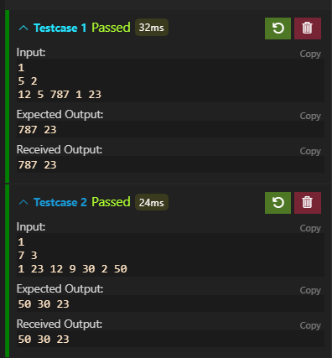

**Understanding about problem:**

* In this task there will be 3 inputs.

1. Length of array
2. K value
3. Array it self

* In this task I need to return vector of largest numbers(k numbers) from main array.

Note: If you can't understand the problem, feel free to contact us and we'll help you. Please don't copy and paste from anywhere.

ALL THE BEST

Team CP Club